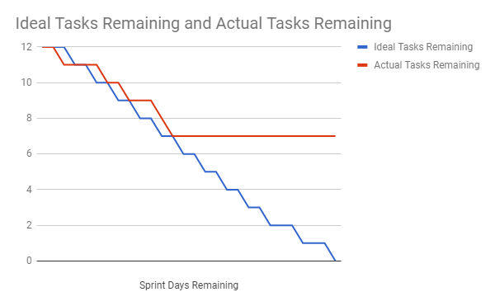

The Sprint 2 Burndown highlights the amount that has been developed throughout the project. The ideal tasks were staged equally throughout the sprint as to ensure proper development. As shown in the graph at the end of the sprint the development team still has 7 tasks remaining for the sprint. This was due to development setbacks and difficulties in design; these tasks will be allocated to the next sprint once agreed upon by the client.

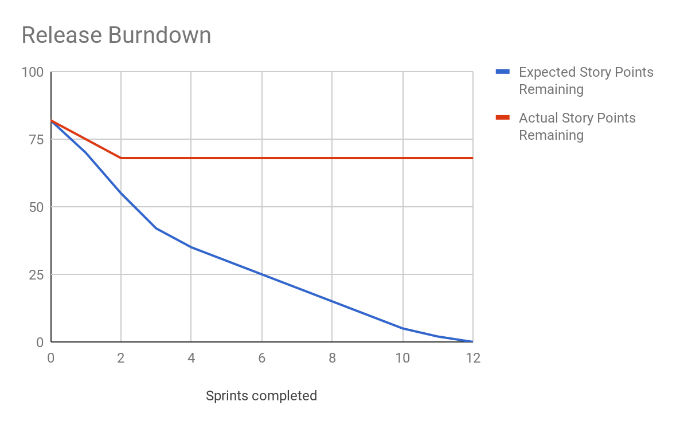

This release burndown exemplifies the story points completed across sprints. Obviously this will be updated during each sprint to reflect how much has been done and the actual story points completed instead of having a flat line after sprint 2.